
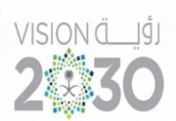

Kingdom of Saudi Arabia Tarbeat Al –Ajial International Schools

Ministry of Education American Section
Hafr Al Baten Directorate
2024/2025

Student’s name |  | Grade | 7
Subject | Computer | Week No. | 4
Lesson Title | 3D Environment | 1st Semester Work sheet No. | 3
Question A: Tick the correct answer.
- Which of the following is the correct pair?
 | Navigation | Hotkey
 | Orbit | Drag MMB
 | Pan | Ctrl + MMB
 | Zoom | Shift + MMB
- Material does not define the __________ of an object.
- Substance b. Color
c. Size d. Texture
Question B: Answer in one line.
- What is 3D viewpoint?
____________________________________________________________
____________________________________________________________

